1st October 2018

**YOKOHAMA Celebrates after the Adriatic Rally**

The 25th Adriatic Rally gave smiles all round to Nicolò Marchioro following his victory in the Italian Rally Terra Championship on the Skoda Fabia R5 of RB Motorsport fitted with YOKOHAMA tyres.

The driver from Este not only managed to be the first on the ground but also climbed places on the overall podium, achieving the third place.

Now Marchioro is the driver to beat in the two races that are still due at the end of the CIRT to challenge the title on the white lands: the “Nido dell’Aquila” scheduled for October 27th- 28th and the Tuscan race scheduled for November 23rd - 24th.

The CIRT ranking now sees Marchioro in the lead with 53 points, followed by Ceccoli with 45 and Trentin with 43. "We brought home a very important result from the Adriatic Rally. The choice of the YOKOHAMA ADVAN A036 tyre was perfect on these terrains: it is the best tyre in the conditions of the terrain typical of these areas. "- said Giuseppe Pezzaioli, Head of Motorsport at YOKOHAMA Italy -" I trust that the last two races on the ground will be equally satisfying and we will put all our efforts and technical support to make the CIRT title return to YOKOHAMA's home. " The appointment is therefore in a month on the exciting paths of Umbria for the “Nido dell’Aquila”.

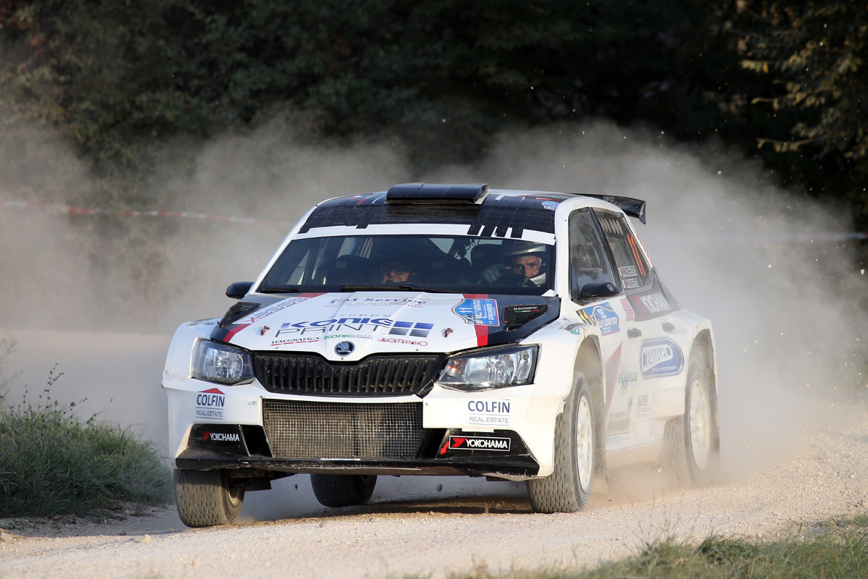

*Marchioro Race*

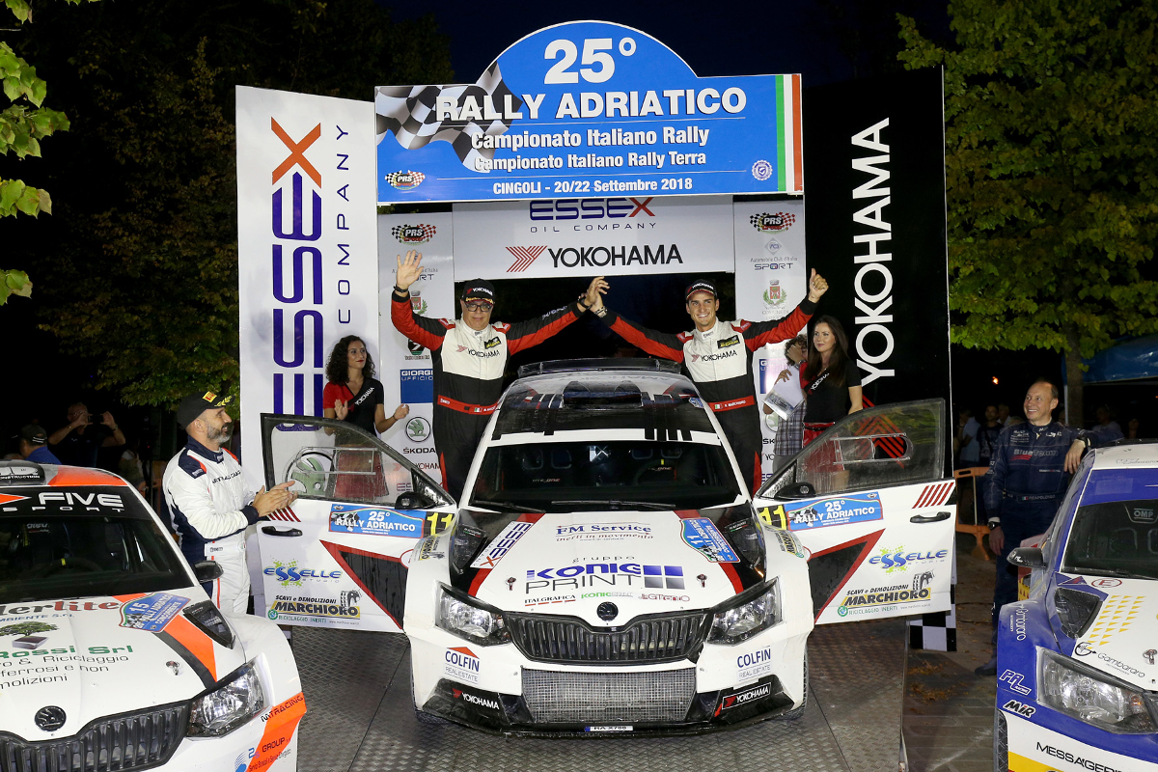

*Marchioro Podium*